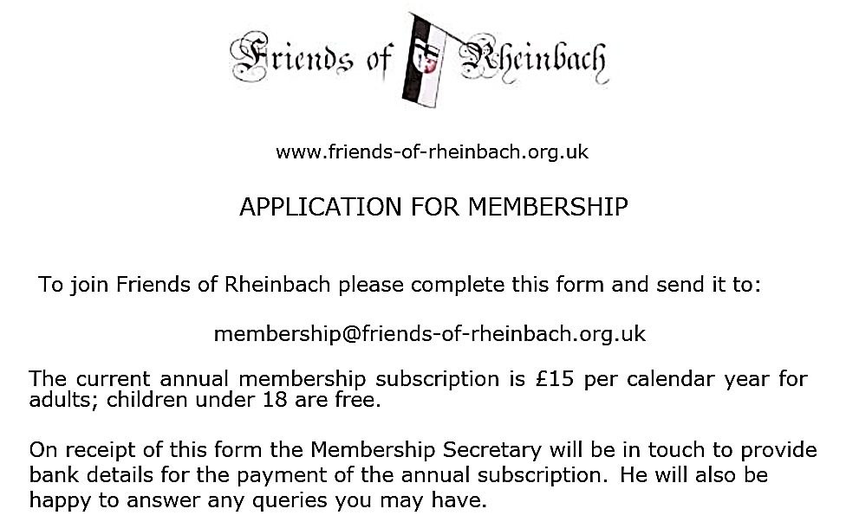

Date

 | Title | Surname | Forename (indicate age if under 18)
1
2
3
4

Full Address
Phone
Email

